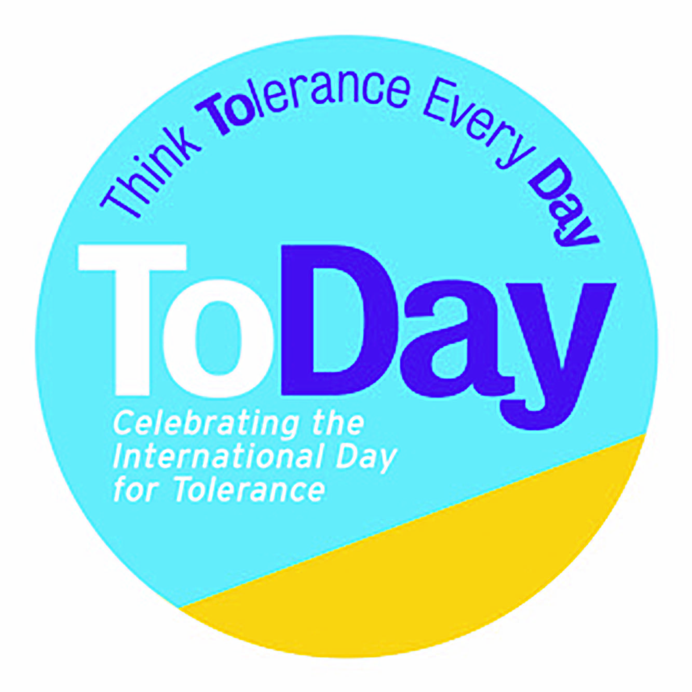

***The ‘Usses’ and the ‘Thems’***

***An Interactive Climate Change Workshop***

|  |  |  |
| --- | --- | --- |
| **Learning Objectives:** Listening, Communicating, Building Empathy, Handling Complexity, Collaborating, Problem Solving | | |
| **Year Group** | KS1 and KS2 Lower  60 mins |  |
| **Introduction** | To solve the issues of climate change we need to learn to balance conflicting interests and handle complexity. |  |
|  | **When animals fight...** | **Timing** |
| Stimulus | Show the Starving Monkey 'GANGS' Battle in Thailand video | 2 $1/2$ mins  1 min |
| Guided Discussion | * What does the future look like for the monkeys in these videos? * How do we learn to share? | 5 mins |
| **Setting up the Conflict** | **Usses versus Thems** |  |
| How conflicts over resources start and escalate | Split class into 2 opposing groups – the Usses start out with all of the paper and the Thems have all the pens.  Read the script – ‘the Battle Between the Usses and the Thems’ (Appendix A), getting 4 pupils to take on appropriate roles for their sides | 3 mins |
| Class Raids (KS2 Lower) | Usses pretend to fall asleep and the Thems send someone over to their side and steal their paper.  Teacher asks Thems to wake up and asks them what’s changed. They see that they have lost their paper. Teacher asks the Thems what they are going to do.  Usses now go to sleep and the Thems mount a tit-for-tat raid.  Ask the class what is likely to happen next? What will it look like next week? | 3 mins |
| Debate versus Dialogue (KS2) | Rock, Paper, Anything Game (Appendix B)  Based on Rock, Paper Scissors this game sets up a debate battle between the Usses and the Thems  Debate involves taking an opposing view and sticking to it. No one gets what they need! | 10 mins |
| **Developing Empathy** | **Asking Questions and Listening to the other side** |  |
| How to move forward? | Teacher:  So, if nothing changes, the future looks fairly grim. We’ve agreed that we all need pens AND paper   * How do we settle things and move forward? * How do we get to understand the other sides point of view? *(ask questions; listen to what they have to say; be heard yourself)* | 2 mins |
| Generating questions; developing curiosity  Listening to each other; seeing other perspectives; building empathy | Question-Storm:   1. Each side is allowed to ask the other side 2 questions 2. Run a question storm (Appendix C) to generate the questions that are most likely to help them understand the other side *(eg. why do you like pens so much? Would you like some paper? What’s your biggest problem with the Usses? What could we do if we worked together?)* 3. Each side to choose their favourite 2 questions 4. Write them each on a separate piece of paper 5. Each side to choose (or the teacher chooses) 2 emissaries to deliver them 6. Usses 1st question is delivered by an emissary to the Thems team, and the Thems team huddle and agree an answer; hands up someone from the Thems to volunteer and deliver the answer to the Usses team 7. Carry on until all 4 questions (2 from each side) have been asked and answered | 3 mins  6 mins |
| **Problem- solving** | **Creative Thinking; Planning a Peace** |  |
| Brainstorm ideas | Now everyone understands each other better.  Using the following question starters, get the whole class to come up with a sharing plan:   * What if we could….? *(both have pens AND paper? Found out we really liked each other?)* * How could we…..? *(share things fairly?)* * Can you imagine how…..? *(much better our classroom would feel?)*   As a class come up with a 3-part agreement and put them it on the classroom wall e.g.   * *Every person gets 4 pens and 8 pieces of paper* * *No one is allowed to steal classroom resources* * *If they do or we have a shortage, we discuss it as a class to come up with a solution* | 5 mins  10 mins |
| **Plenary** | **What did we learn about sharing resources?** |  |
| Class discussion/  homework | Research some real-world examples of where the things people need are not fairly share e.g. COVID vaccines |  |

## Appendix A

### **THE BATTLE BETWEEN THE ‘USSES’ AND THE ‘THEMS’**

The class is separated into 2 ‘gangs’ – the Usses and the Thems. They face off against each other on opposite sides of the class-room.

Teacher:

The Usses and the Thems want to protect what they have but know they need what the other side has to make their lives better.

Usses Pupil 1 “The Thems are all so sneaky. They never share. I’m sure they want to steal our paper.”

Thems Pupil 1 “I can see the Usses eying our pens. They are so greedy and can never have enough.”

Teacher:

Usses, show the Thems how much you dislike them

Thems, you show the Usses what you feel about them

Usses Pupil 2 “Paper is our passion. We can never have enough of it. But we do need pens Let’s organise a raid!”

Thems Pupil 2 “Pens are great but paper is the key to our success. We have to get some.”

### Appendix B

### **THE ROCK, PAPER, ANYTHING GAME**

This game is a great way for children to engage in a mini-conflict debate with someone from the other side in a non-threatening manner and to discover that sticking to your version does not end conflict.

Ask participants to find a partner from the other ‘gang’ ie. A pair made up of someone from the Usses and the Thems side.

1. Have each pair stand face to face, right fist out (as in Rock, Paper, Scissors), and say together, “Rock, Paper, Anything!”
2. Once the word *anything* is said, the two participants yell out the name of any item they can think of (dog, television, shoe).
3. After yelling out their items, team members must now debate one another as to why their item would “beat” the other person’s item.
4. Allow about two minutes of debate, then call a brief time-out to discuss the difference between this kind of debate and real dialogue or discussion.

***Tips***

The essential difference between debate and dialogue is that true dialogue is collaborative. Participants are working toward shared understanding and strength and value in each other’s positions.

A debate is a discussion with the goal of persuading or advocating for their own view, attempting to prove the other side wrong, and searching for flaws and weaknesses in the other’s positions.

Dialogue allows people to develop understanding for one another’s perspectives, thoughts, and feelings as well as to reevaluate their own position in light of the other’s understanding.

Discussion Questions

* How did you react to your mini-conflict?
* Is it difficult to listen when someone disagrees with you? Why?
* Is this how you normally act in conflict situations? Why or why not?

### Appendix C

### **QUESTION-STORM**

This is a twist on a brain-storm. It takes between 1-3 mins to do – you can spend as long as you like discussing the results. It gets pupils comfortable and capable of generating volumes of simple questions.

First chose the topic you want to question-storm, in this case “what do you want to know about your arch enemy, so you can understand them better?”

Intro:

* The task is to generate as many questions as possible, without judgement or editing
* Use simple Who? What? When? Where? Why? and How? Question stems
* You can either do 1 question stem at a time for 30 seconds, or remind them of all six and give them 1 minute to generate as many questions as they can (use a giant egg timer for fun)

Class instructions:

* Right, let’s do a question-storm
* Make sure you have paper and pen – oops, Usses you will have to give the Thems some pens and Thems you will need to hand over some paper to the Usses
* The game is to write down as many questions as you can
* You have 1 minute to write down as many questions as you can – minimum 5 each
* The big egg timer will show you how long you’ve got
* There are no good or bad/right or wrong questions
* On your marks get set, go!

Each side collects their results:

* Each pupil pick your favourite and share with your group
* As a group pick your top 3 (show of hands)