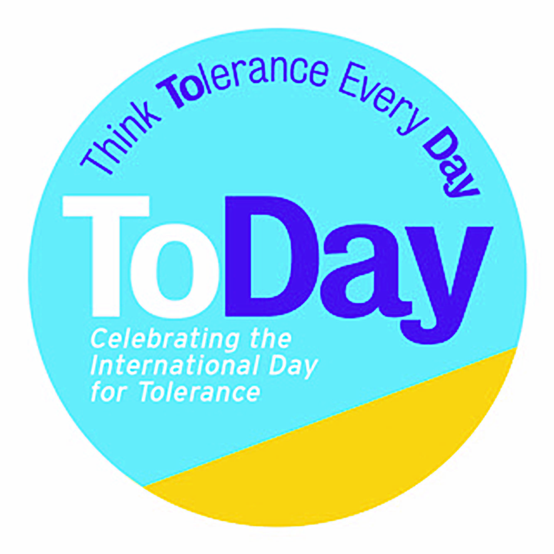

WHOLE SCHOOL

Tolerance and Diversity Giant Paper Chain Morning Work Activity

Learning Objectives: Creativity, teamwork, communication skills

Materials: A4 printer paper, art and craft materials for decorating, glue/Sellotape, scissors.

Activity: Children to decorate a link each, perhaps with relevant words around Tolerance e.g. Diversity, Compassion, Respect, Dialogue, Resilience, Understanding, United, Rights, Kindness.

The teacher starts with the first link and each child adds theirs until the class has made their chain. A ‘chain bearer’ then takes their class chain to the next classroom and so on until each group of classrooms have made their chain. Teachers to unite the whole school’s chains where possible up and down corridors, halls etc. Leave in place as Christmas decorations.

——————————————————————————————————————————————————————————————————————————————————

——————————————————————————————————————————————————————————————————————————————————-

——————————————————————————————————————————————————————————————————————————————————

DIVERSITY
COMPASSION
FREEDOM
RESPECT

