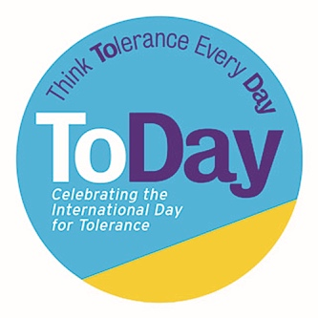

Whole School: ‘Hat Swap’
Tolerance and Diversity Morning Work Activity

Learning Objectives: Creativity, collaboration, communication skills, empathy

Materials: A3 printer paper, art and craft materials for decorating, glue/sellotape, scissors.

Activity:
- Children pick a random name of another pupil or member of staff out of a hat – they have to make their special hat for this person, put the person’s name on it and decorate it for them

- BUT first they have to find out more about this person by asking 3 simple questions. The class could work on this together and decide on 3 questions, OR use these examples:
  - What’s your favourite food?
  - What do you like to do best outside school time?
  - Who do you most admire?

- Children to make a simple folded paper hat (click on this link or use the folding instructions below), pt the other person’s name on it and decorate it

- They then have to put on their hat and become the other person, introducing themselves with the information they have gathered by asking the questions

- At the end of the activity they gift their hat to the other person. Re-purpose as Christmas party hats at the end of term.

