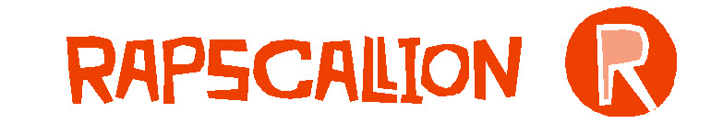
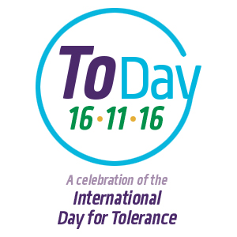

‘Journey to the Beginning of the World’
Lesson Plan for Keystage 2 Lower
This plan and those for further year groups downloadable at www.toleranceday.org

TOPIC: Religious tolerance, World religions, conceptual questions, critical thinking

Year Group | Keystage 2 Lower (Years 3 & 4)
Curriculum Area | RS, SMSC (community cohesion)  English – Spoken and written language
Learning Objectives | - Pupils will learn that some questions have no agreed upon answer – ie. are conceptual or philosophical  - They will learn that ‘how was the world made?’ Is a conceptual question and people have many ways of answering it  - None of the answers is ‘right’ or ‘wrong’, it’s a matter of what a person believes or what they understand  - Pupils will discover that they will have different answers and will have a variety of reasons for believing them
Teacher Input |  | To Include | Timing
 | Opener | Games to explain types of questions  See Powerpoint | 5 mins
 | Stimulus | 4 different answers to how the world was made - resources  Powerpoint | 15 mins
 | Things to think about | Why is there not just one answer? How are the answers different and how are they the same?
Class Activities
 | Discussion | Paired share about which your favourite answer was and why; hands up for a few students to share with the class (NB. they can like more than one, or none) | 10 mins
 | Discussion | Why are there different answers? Students to share their ideas with the class | 10 mins
 | Optional | Discuss - what other questions are like this ie. that are important to all of us and don’t have agreed upon answers? | 15  mins
Plenary | Summing up | Paired share – What did you learn about different types of questions? What did you learn about answer to ‘How was the World Made?’
Homework/  follow-on work |  | Ask the adults at home how they think the world was made and record their response. Was their answer what you thought it would be? Is it different to your own?  OR think of and record 3 more conceptual questions that interest you
Follow-up lessons |  | Rights and Freedoms
Assessment

