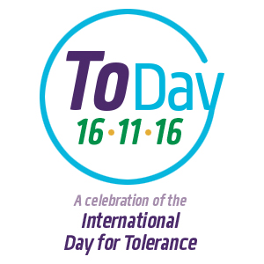

‘Journey to the Beginning of the World’
Lesson Plan for Keystage 1
This plan and those for further year groups downloadable at www.toleranceday.org

TOPIC: Religious tolerance, World religions, conceptual questions, critical thinking

Year Group | Keystage 1 (Years 1 & 2)
Curriculum Area | RS, SMSC (community cohesion)  English – Spoken
Learning Objectives | - Pupils will learn that some questions have no agreed upon answer – ie. are conceptual  - They will learn that ‘how was the world made?’ Is one of these questions and it has many answers  - None of the answers is ‘right’ or ‘wrong’, it’s a matter of what a person believes  - The pupils in the class have different answers and beliefs, and that’s ok
Teacher Input |  | To Include | Timing
 | Opener | Games to explain types of questions  See Powerpoint | 5 mins
 | Stimulus | 4 different answers to how the world was made - resources  Powerpoint | 15 mins
 | Things to think about | How are the answers different and how are they the same? Why is there not just one answer?
Class Activities
 | Discussion | Paired share about which your favourite answer was and why; hands up for a few students to share with the class (NB. they can like more than one, or none) | 10 mins
 |  | Why are there different answers? Students to share their ideas with the class | 10 mins
 | Optional – ‘Create your own world’ drawing activity | Draw a picture of the world you would create, including the creatures that would live there | 15  mins
Plenary | Summing up | Paired share – What did you learn about different types of questions? What did you learn about answer to ‘How was the World Made?’
Homework/  follow-on work |  | Ask the adults at home how they think the world was made and record their response. Was their answer what you thought it would be? Is it different to your own?
Follow-up lessons |  | Rights and Freedoms
Assessment

