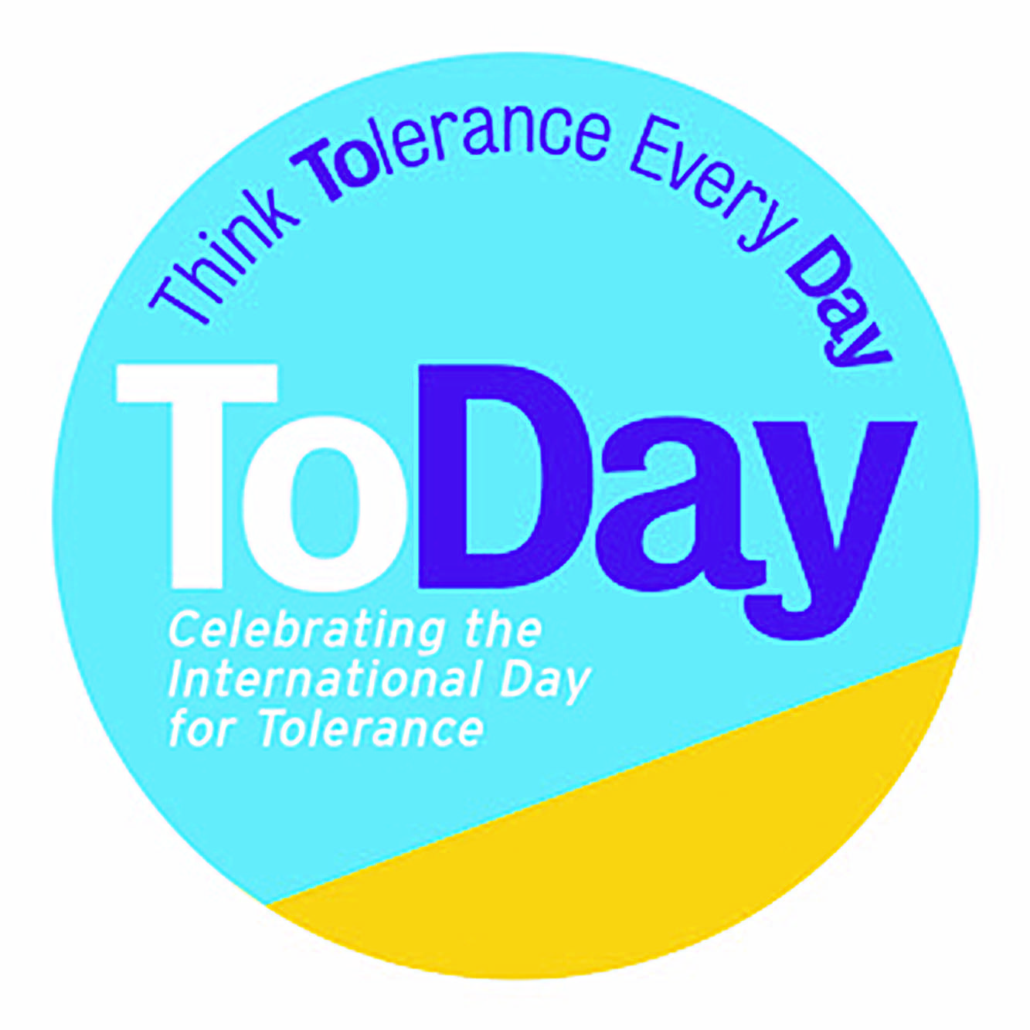

***Reds v Blues***

*A Conflict Resolution Workshop*

|  |  |  |  |
| --- | --- | --- | --- |
| **Skills:** Listening, Communicating, Building Empathy through Questioning, Controlling Emotions, Problem Solving | | | |
| **Year Group** | KS2  Suggested for History or PSHE  60 mins |  |
| **Objectives & format** | To learn and practice crucial social, emotional and thinking skills  This action filled multi-part session has all pupils role-play a ‘battle’ scenario and then listen, question, communicate, and problem-solve their way out of it  They will learn the difference between debate and dialogue, how questions create empathy with others, how important it is to control emotions, and how creativity and communication can drive a better result for everyone |  |
| **Introducing the idea** | **When animals fight...** | **Timing** |
| Stimulus | Show [Fighting Hippos](https://www.youtube.com/watch?v=vHXB_IqJSNA&frags=pl%2Cwn) and the [Starving Monkey 'GANGS' Battle in Thailand](https://www.youtube.com/watch?v=3WM8ead33Fk&frags=pl%2Cwn) video | 2 $1/2$ mins  1 min |
| Guided Discussion | Ask the class:   * What does the future look like for the hippos and the monkeys in these videos? * Where in our History classes or in the world today have we seen humans involved in violent conflict, just like the hippos? * Why? What is it about animals that is different to humans? * What do humans use to settle arguments? (*we have developed language to reason and communicate; we can also control our emotions* | 5 mins |
| **Setting up the Battle** | **Reds versus Blues** |  |
| How conflicts start and escalate | Split class into 2 opposing groups – the Reds and the Blues. The Reds and the Blues both start out with a large pile of paper and pens.  [You could instead replace with battles you have looked at in History or English – Vikings vs. Anglo Saxons; Mayans vs. Spanish; Montagues vs, Capulets]  Read the script – ‘the Battle Between the Reds and the Blues’ (Appendix A), getting 6 pupils to take on appropriate roles for their sides | 3 mins |
| Class Raids (KS2 Lower) | Blues pretend to fall asleep and the Reds send someone over to their side and steal their pens.  Teacher asks Blues to wake up and asks them what’s changed. They see that they have lost their pens. Teacher asks the Blues what they are going to do.  Reds now go to sleep and the Blues mount a tit-for-tat raid.  Ask the class what is likely to happen next? What will it look like next week? | 3 mins |
| Debate versus Dialogue (KS2 Upper) | Rock, Paper, Anything Game (Appendix B)  Based on Rock, Paper Scissors this game sets up a debate battle between the Reds and the Blues  Debate involves taking an opposing view and sticking to it. It will not solve a conflict! | 10 mins |
| How do you feel? | Teacher:   * Now you are all fired up, close your eyes, describe how do you feel? At what other times do you feel like this? * Feeling like this do you think you can make good decision? Why not? | 2 mins |
| What happens next? | Teacher asks:   * What is likely to happen next between the Reds and the Blues? *(no one can write or draw, so no school)* * If the battle carries on for another year, what could happen? *(whole school and parents take sides)* * Who is actually winning? *(no-one)* * What would be better for both sides? *(to have paper AND pens!)* | 5 mins |
| Controlling Emotions | Teacher:   * When you are angry and upset your body and mind are in fight or flight mode. The part of your brain that reasons and makes good decisions is not working * Let’s help our bodies and minds calm down * It’s actually very simple to do, we just show our minds that it’s all calm now by taking long deep breaths * Breathe in for 4 counts; breath out for 4 counts * Repeat 5 times * Now we are calm we can think about how we can end this battle..... |  |
| **BREAK** |  | 4 mins |
| **Developing Empathy** | **Asking Questions and Listening to the other side** |  |
| How to move forward? | Teacher:  So, if nothing changes, the future looks fairly grim. We’ve agreed that we need to find peace so that we can all have pens AND paper   * How do we settle things and move forward? NB. you have to do it between yourselves, you can’t ask the Headteacher because they have given up! *(understand the other sides issues; what is it that they really want?)* * How do we get to understand the other sides point of view? *(ask questions; listen to what they have to say; be heard yourself)* | 2 mins |
| Generating questions; developing curiosity  Listening to each other; seeing other perspectives; building empathy | Question-Storm:   1. Each side is allowed to ask the other side 3 questions 2. Run a question storm (Appendix C) to generate the questions that are most likely to help them understand the other side *(eg. why do you like pens so much? Would you like some paper? What’s your biggest problem with the Reds? What could we do if we worked together?)* 3. Each side to choose their favourite 3 questions 4. Write them each on a separate piece of paper 5. Each side to choose (or the teacher chooses) 3 emissaries to deliver them 6. Red’s 1st question is delivered by an emissary to the Blue team, and the Blue team huddle and agree an answer; hands up someone from the Blues to volunteer and deliver the answer to the Red team 7. Carry on until all 6 questions (3 from each side) have been asked and answered | 3 mins  6 mins |
| **Problem- solving** | **Creative Thinking; Planning a Peace** |  |
| Brainstorm ideas | Now everyone understands each other better.  Using the following question starters, get the whole class to come up with a peace plan:   * What if we could….? *(both have pens AND paper? Found out we really liked each other?)* * How could we…..? *(share things fairly?)* * Can you imagine how…..? *(much better our classroom would feel?)*   As a class come up with a 3 (or more) part agreement or treaty and put them it on the classroom wall e.g.   * *Every person gets 4 pens and 8 pieces of paper* * *No one is allowed to steal classroom resources* * *If they do or we have a shortage, we discuss it as a class to come up with a solution*   Get pupils to devise a peace celebration to bring the Reds and the Blues together eg. PJs and a movie afternoon, something purple themed | 5 mins  10 mins  Extra |
| **Plenary** | **What did we learn about solving arguments?** |  |
| Class discussion/  homework | Write down the top 3 things you have learnt about how to solve:   * an argument you may have with an individual or group * groups in a wider conflict either that you know about from History or in the world today   What are you now going to do differently? | 4 mins  OR extra |

## Appendix A

### **THE BATTLE BETWEEN THE REDS AND THE BLUES**

The class is separated into 2 ‘gangs’ – the Reds and the Blue. They face off against each other on opposite sides of the class-room.

Teacher:

The Reds and the Blues really really HATE each other. No one can really remember when or how the dispute started, but rumour has it that last term a kid called Roger stole Bob’s pen, so Bob stole Roger’s paper. Then their friends got involved and soon everyone in the class was split between Roger – the REDS, or Bob – the BLUES.

Red Pupil 1 “The Blues are all so sneaky. They lie about everything. You can never trust them.”

Blue Pupil 1 “Why do all the Reds smell so bad? I heard that it’s because they eat frogs for breakfast.”

Red Pupil 2 “The Blues are so strange. I think they must be aliens or something. I just don’t think they are from the same planet as us.”

Blue Pupil 2 “The Reds are the worst. Not only do they eat weird stuff, they look weird and they act weird.”

Teacher:

Reds, show the Blues how much you dislike them

Blues, you show the Reds what you feel about them

Red Pupil 3 “Pens are our passion. We can never have enough of them. Let’s organise a raid!”

Blue Pupil 3 “Paper is the key to our success. We have to get more.”

### Appendix B

### **THE ROCK, PAPER, ANYTHING GAME**

This game is a great way for children to engage in a mini-conflict debate with someone from the other side in a non-threatening manner and to discover that sticking to your version does not end conflict.

Ask participants to find a partner from the other ‘gang’ ie. A pair made up of someone from the Red and the Blue side.

1. Have each pair stand face to face, right fist out (as in Rock, Paper, Scissors), and say together, “Rock, Paper, Anything!”
2. Once the word *anything* is said, the two participants yell out the name of any item they can think of (dog, television, shoe).
3. After yelling out their items, team members must now debate one another as to why their item would “beat” the other person’s item.
4. Allow about two minutes of debate, then call a brief time-out to discuss the difference between this kind of debate and real dialogue or discussion.

***Tips***

The essential difference between debate and dialogue is that true dialogue is collaborative. Participants are working toward shared understanding and strength and value in each other’s positions.

A debate is a discussion with the goal of persuading or advocating for their own view, attempting to prove the other side wrong, and searching for flaws and weaknesses in the other’s positions.

Dialogue allows people to develop understanding for one another’s perspectives, thoughts, and feelings as well as to reevaluate their own position in light of the other’s understanding.

Discussion Questions

* How did you react to your mini-conflict?
* Is it difficult to listen when someone disagrees with you? Why?
* Is this how you normally act in conflict situations? Why or why not?

### Appendix C

### **QUESTION-STORM**

This is a twist on a brain-storm. It takes between 1-3 mins to do – you can spend as long as you like discussing the results. It gets pupils comfortable and capable of generating volumes of simple questions.

First chose the topic you want to question-storm, in this case “what do you want to know about your arch enemy, so you can understand them better?”

Intro:

* The task is to generate as many questions as possible, without judgement or editing
* Use simple Who? What? When? Where? Why? and How? Question stems
* You can either do 1 question stem at a time for 30 seconds, or remind them of all six and give them 1 minute to generate as many questions as they can (use a giant egg timer for fun)

Class instructions:

* Right, let’s do a question-storm
* Make sure you have paper and pen – oops, Reds you will have to give the Blues some pens and Blues you will need to hand over some paper to the Reds
* The game is to write down as many questions as you can
* You have 1 minute to write down as many questions as you can – minimum 5 each
* The big egg timer will show you how long you’ve got
* There are no good or bad/right or wrong questions
* On your marks get set, go!

Each side collects their results:

* Each pupil pick your favourite and share with your group
* As a group pick your top 3 (show of hands)

### Appendix D

### **C.L.I.C.C. to MAKE PEACE**

C

Collaborate

Create

Imagine

Listen

Control Emotions