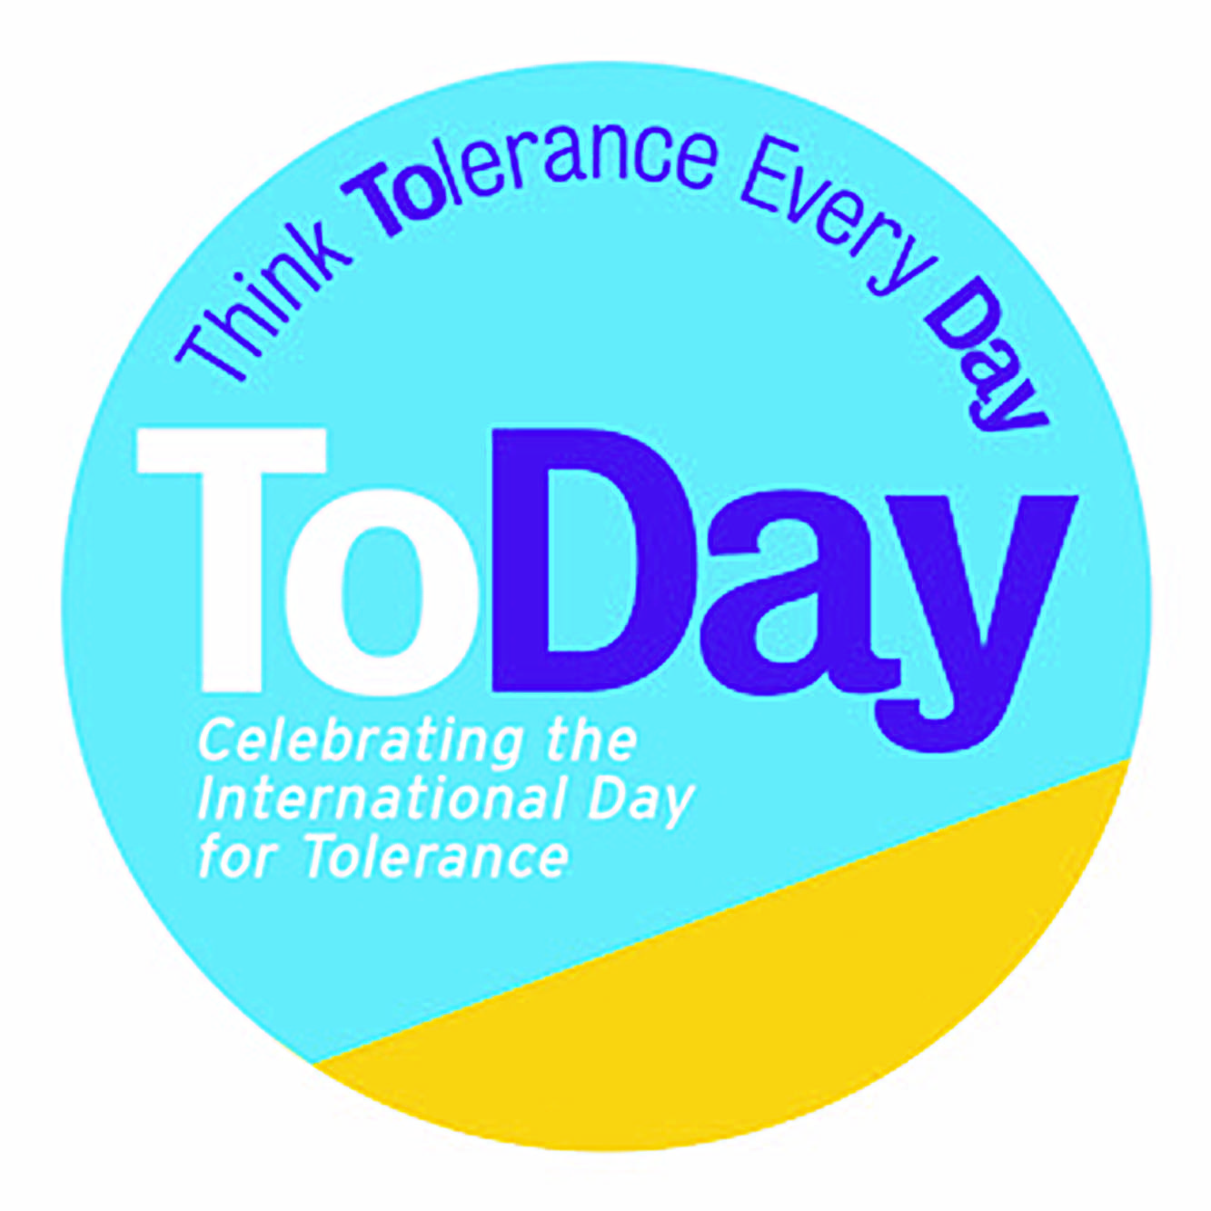

**Overview of Lesson Plans and Projects 2020**

**‘Resolving Conflict to Build a Positive Future’**

**Available on-line at www.toleranceday.org**

To mark the UN's International Day for Tolerance on 16th November 2020, Learn2Think has added some new fun, thoughtful and challenging resources to the existing resource- bank that will help children resolve conflict and build a positive future.

Learn2Think is making free curriculum linked lesson plans, games, workshops, reading lists, and activities available on-line, all based on the latest educational research and thinking. As well as using proven social and emotional learning techniques, these resources are rooted in the belief that students need to be active in their learning – to not just be given a text book to read but to actively ‘play the game’.

Particular skills are being developed and have been colour coded for ease of use by teachers. These are:

|  |  |  |
| --- | --- | --- |
| * listening and communication | |  |
| * building empathy | |  |
| * controlling emotions | |  |
| * problem solving | |  |
|  |  | |

Specially written books will engage children in critical thinking around understanding perspectives, religious tolerance, handling misinformation, the complex nature of truth/opinion/bias. Please let us know if you want to receive a free book pack for your school.

Children are also being encouraged to compete for the Young Journalist Prize 2020 during Non-Fiction November, this year focused on interviewing people with differing opinions.

*Plans tailored specifically to year groups are indicated below and are available to download on-line at www.toleranceday.org.*

**For 2020**

*The Reds versus the Blues* - This action filled multi-part session has all pupils role-play a ‘battle’ scenario and then listen, question, communicate, and problem-solve their way out of it.

They will learn the difference between debate and dialogue, how questions create empathy with others, how important it is to control emotions, and how creativity and communication can drive a better result for everyone.

**English**

FOR NON-FICTION NOVEMBER

*Young Journalist Competition* – Get pupils to apply their non-fiction writing and production skills by entering the Learn2Think young journalism prize. This year the focus of their 500 word piece or 3-5 minute podcast is on interviewing people with opposing views. See the [details of how to apply](http://www.toleranceday.org/young-journalist-prize-2020.html). Students can win a Kindle and a trophy.

Ages 8-11

*The Truth Detectives* gets children thinking like a (responsible) journalist. This lesson develops the questioning, listening, assessing and communication skills that add breadth, depth and perspective to students’ writing. When a controversial incident occurs at school, can they get to the bottom of what really happened? Includes a downloadable poster of a set of cute characters to reinforce the need to ask, ‘Who, What, When, Where, Why and How?’

Key-stage 2 Upper

LITERACY

*‘The Butter Battle’*, by Dr Seuss. The population is divided between those that butter their bread up and those that butter it down. This ‘dangerous’ difference makes neighbours distrustful of each other, so much so that they build a wall to keep themselves ‘safe’ and hostilities escalate until they risk mutual annihilation with the ‘Big Boy Boomeroo’. How could this have been avoided?

Keystage 1

Keystage 2 Lower

*‘The Sneetches’*, by Dr Seuss - In 1998 NATO distributed copies of this book to children in Bosnia and Herzegovina as part of a campaign to encourage tolerance. Dr Seuss wrote it to satirise intolerance and anti-Semitism in 1953. This set of lesson plans gets pupils to actively engage with the idea of intolerance and how it can be dramatised via story-telling.

Reception, Key-stages 1&2

SPECIAL TOLERANCE DAY BOOKS– *available free by contacting info@toleranceday.org.uk*

*‘Journey to the Beginning of the World’ -* this lesson teaches children what a conceptual question is and then uses ‘how was the World made?’ as an example. Four versions of how the world was made - Chinese, Christian, Hindu and scientific - are presented and pupils get to discuss why there are multiple answers.

Keystage 1

Keystage 2 Lower

Keystage 2 Upper

*‘Chameleon Boy Meets the Mammal Monsters’* is the stimulus for a lesson that demonstrates how questions help to connect you with a character and deepen your thinking. It also explores how fear and imagination can be used in their creative writing.

Key-stage 2

*Perfect Worlds* -This is a thought-provoking creative writing exercise using Chapter book, *‘Who Made you the Boss?’* and *‘Babar the King’* as inspiration. Gets pupils thinking about what they don’t like about the world they live in now. They then create their own ‘perfect worlds’.

Key-stage 2 Upper

**PSHE**

*Resisting Intolerance* - a lesson that helps pupils understand the brain science at work when they get angry and provides them with tools to manage anger positively,

Reception

Keystage 1

Keystage 2 Lower

Keystage 2 Upper

**Relevant Materials From the Resource Bank**

**Art**

*‘Perspective Circle’* - an engaging exercise using Picasso and the cubists to explore different viewpoints and the challenges of working as a team.

Keystages 1& 2

**Assembly**

*For Tolerance Day (Approx15 mins)*

A whole school interactive assembly that explains what Tolerance Day is, why we need it and what the school is doing to celebrate it. It includes a game in which pupils experience for themselves how intolerance can cause division.

Whole school – PPT

*A Whole- Class Dramatisation of ‘Journey to the Beginning of the* World’ - exploring the epic stories cultures have told throughout the ages about how the earth was created. Created and tested by Y5, Grafton Primary, Islington, London.

Key-stage 2 Upper

**Form time**

*Paper chain craft activity* for the whole school community to celebrate ToDay together .

Whole School

*‘Swap hats’ craft activity* gets pupils to imagine what it’s like to be someone else. They chose another person to be, ask them 3 simple questions to find out a bit more about them, and then make a hat and ‘become’ that other person.

Whole School

**History**

*‘Understanding Rights and Freedoms’* uses the *‘Magna Carta Chronicle’* to look at how intolerance has restricted people’s freedoms throughout history. Pupils imagine being an historical character and argue from this alternate perspective about why certain rights and freedoms should be restricted or upheld.

Keystage 1

Keystage 2 Lower

Keystage 2 Upper

*‘42 Moments in World History’*- a giant colourful poster activity available free by contacting [info@toleranceday.org.uk](mailto:info@toleranceday.org.uk) asks children to step back and connect the dots of the past. On the poster they will fill in what they consider to be the 42 key moments of history, 7 for each region of the world. It will broaden children’s perspectives and get them to acknowledge the role all cultures have played in creating the world we live in today. For copies of the poster e-mail info@learn2think.org.

Key-stage 2 Upper

*Amy Buller’s, ‘Darkness Over Germany’* – a new perspective on the rise of Hitler and the radicalization of young Germans in the later 1930s. Real life stories of young people who used critical thinking and courage to stand up to Nazism, teach the importance of primary sources and of empathy in understanding major political movements and divisions.

Keystage 2 Upper

Keystage 3

**Library**

Tolerance Day Recommended Reading List - top picks for books approaching discussions around Tolerance.

Whole School

**Maths/ICT**

[Add link] The Tolerance Day Survey - a Survey Monkey on-line survey that asks pupils about their own experiences of conflict and intolerance. Data will be compiled and used with influencers and with the media. It’s the pupil’s opportunity to have their voices heard at a national level. Deadline 23rd October so that we have the results for Tolerance Day.

Whole School

*The ‘DNA’ of our class/school* - following the national curriculum requirement for statistics, this lesson plan asks pupils to survey their class (and for Years 5 & 6 their school) to reveal the levels of diversity. They then have to present this information in graph form.

Reception

Keystage 1

Keystage 2 Lower

Keystage 2 Upper

**PSHE/Citizenship**

*Half Day ‘Truth detective’ workshops* –age targeted games, activities and discussions that teach basic research and investigative techniques to help in getting as close to the truth of a story as possible.

Keystage 2 Upper

*‘Chameleon Boy’* book, gets pupils to build resilience and learn to think for themselves by exploring fear - of the unknown, of change and of difference. Also, of the dangers of believing everything you read on-line.

Key-stages 1 & 2

**RS/SMSC**

*‘Journey to the Beginning of the World’* - this lesson teaches children what a conceptual question is and then uses ‘how was the World made?’ as an example. Four versions of how the world was made - Chinese, Christian, Hindu and scientific - are presented and pupils get to discuss why there are multiple answers.

Keystage 1

Keystage 2 Lower

Keystage 2 Upper

*A full archive of valuable tolerance and diversity related lesson plans from 2016 to 2019 are available at* [*www.toleranceday.org*](http://www.toleranceday.org)*.*