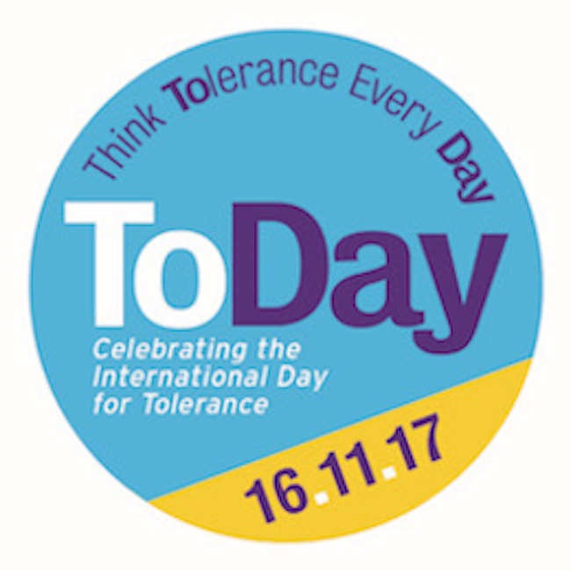

***‘Who Made You the Boss?***

***Looking at the pros and cons of political systems***

*Lesson Plan for KS2*

*This plan is downloadable at www.toleranceday.org*

|  |  |  |
| --- | --- | --- |
| **TOPIC:** Understanding complexity; at least 2 sides to every story | | |
| **Year Group** | KS2 |  |
| **Curriculum Area** | English – 30 min lesson  Citizenship, Current Affairs |  |
| **Learning Objectives** | * Looking beyond what you initially see and think * Challenging your pre-conceptions * Understanding the text and eliciting pros and cons from dialogue |  |
| **Introducing the idea** | **Activity** | **Timing** |
|  | This is designed as a follow-up comprehension lesson to reading chapter book, ‘Who Made you the Boss?’ |  |
| **Class Activities** |  |  |
| **What do you think you know?** | What political system do we have in the UK?  Would you consider it the best system? Why? |  |
| **Pros and Cons** | The book identifies 4 different types of political system –   1. Representative Democracy 2. One party state 3. Authoritarian and/or hereditary regime 4. A country run by a business-man, Manners World   Can you think of any real-life examples of each system (NB. Number 4 is currently just an idea and doesn’t exist yet)  Using the text to help, can you:   1. Describe each system 2. Explain their approach to educating their children 3. Identify some of the pros and cons of each |  |
| **Challenging pre-conceptions** | Do you think any differently about political systems now? |  |
| **Home work** | Research 5 countries of your choice and identify what type of political system they follow. NB many are mixed or hybrids |  |
| **Follow-on work** | Imagine a world without school  Utopias |  |