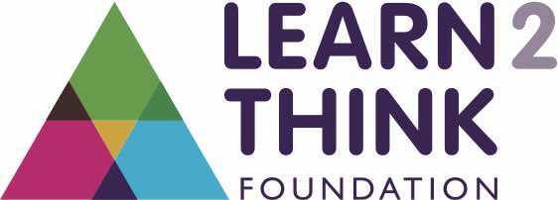
The Learn2Think Young Journalist Prize 2021/22
Lesson Plan for Key-stage 2

This is a journalism competition open to all Key-stage 2 age pupils. This year the theme is Climate Change

Year Group | Key-stage 2
Curriculum Areas | Goes across Science, English, Geography, PSHE
Learning Outcomes | - Communication skills – asking relevant questions and listening  - Distinguishing between statements of fact and opinion  - Retrieving, recording and presenting accurate information  - Reporting on findings from enquiries  - Citizenship
Classroom Activities |  |  | Timing
 | Quiz | Link to our climate quiz. We guarantee that it will encourage pupils to look at climate change differently and more thoughtfully.  https://docs.google.com/presentation/d/1ubj3mvlfb_szX5ceXsXeIQKQtMSIVE8QfQmx1lJ0rcs/edit?usp=sharing | 5 mins
 | Worksheet | A simple worksheet to help pupils chose a topic, identify sources and chose a person to interview | 15 mins
The Competition Guidelines
 | Who can apply? | Open to any child aged between 8 and 11 (at time of submission).
 | Topic | Climate Change (complete the worksheet to help plan an entry).
 | What the judges would like to see | An article of up to 500 words or a podcast of up to 3 minutes.
 | What will the judges be assessing? | Voice: Your own voice (not your parents or teachers).  Research: Breadth; use a range of credible sources  Interview: Good quality questioning
 | Prizes | The overall winner will receive a Chromebook (or similar) laptop for themselves OR their school. Runners up prizes include a Kindle, book vouchers and a free author visit/workshop from the Learn2Think Foundation.
 | Send entries to..... | Via e-mail to learn2thinkfoundation@gmail.com or handwritten to 39A Princess Road, London, NW18JS.

