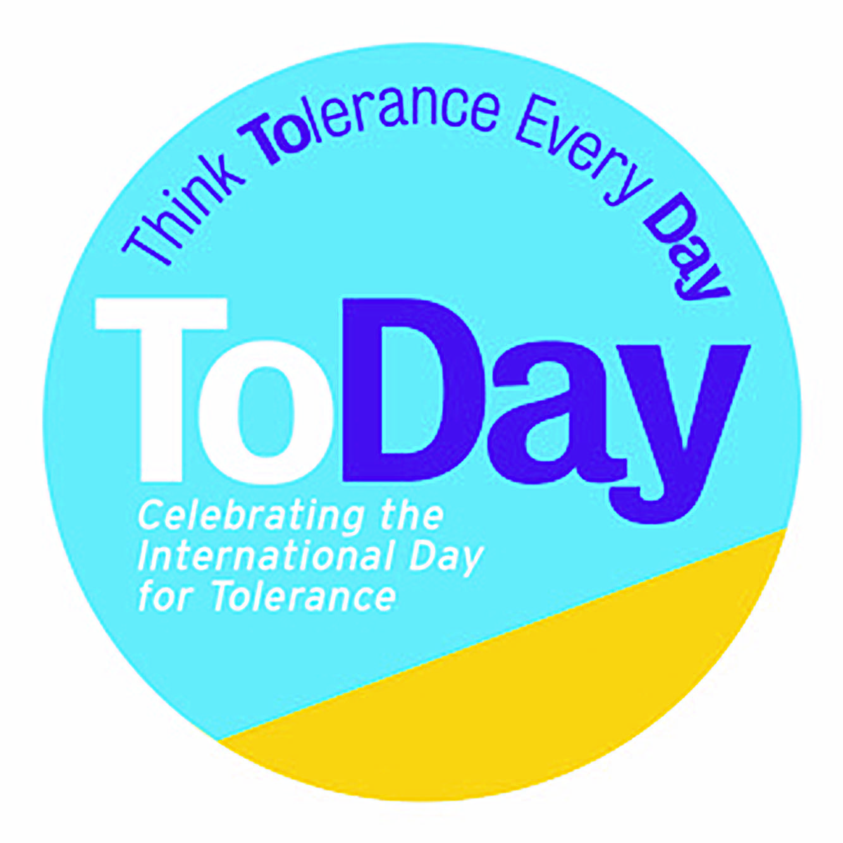

***‘The Sneetches’***

***Lesson Plan for Key-stage1; PSHE, Drama***

*This plan and those for further year groups downloadable at www.toleranceday.org*

|  |  |  |  |
| --- | --- | --- | --- |
| **Themes**: Tolerance, Difference, Fairness, Empathy, Moral Complexity, SMSC | | | |
| **Year Group** | English– spoken & written; PSHE; Drama  1 hour | | |
| **Skills Developed** | Listening and communication  Developing empathy  Problem solving | | |
| **Learning Objectives** | * Ability to articulate a basic understanding of difference, tolerance and fairness * Begin to understand how it might feel to be discriminated against * To retell the story by acting it out to demonstrate understanding | | |
| **Teacher Input** |  | **To Include** | **Timings** |
|  | Opener Activity | Take 2 children and ask the class to point out how they are different and how they are the same | 3 mins |
|  | Stimulus | Read ‘The Sneetches’, by Dr Seuss  OR  Watch  <https://www.youtube.com/watch?v=PdLPe7XjdKc> | 8mins  12mins |
|  | Things to think about | Ask the children to notice how some of the creatures feel like they are better than the others |  |
| **Class Activities** |  |  |  |
|  | Discussion/Paired Share | - Have you ever felt left out?  - Have you ever left someone out?  - Why do some people leave other people out?  - Was Sylvester’s behaviour good or bad?  - How did the Sneetches change the way they thought by the end?  - What advice would you give the Sneetches? | 10 mins |
|  | Activity | Retelling the story by acting it out  - Listen to the story again  - See appendix for guidance and required materials (RSneetch1) | 10 mins  10 mins |
| **Plenary** | Discussion | E.g. Just because you are different it doesn’t make you better or worse; it’s never OK to treat someone else badly, especially because they are different from you |  |
| **Follow-up lessons** | ‘Journey to the Beginning of the World’ – difference in belief |  |  |