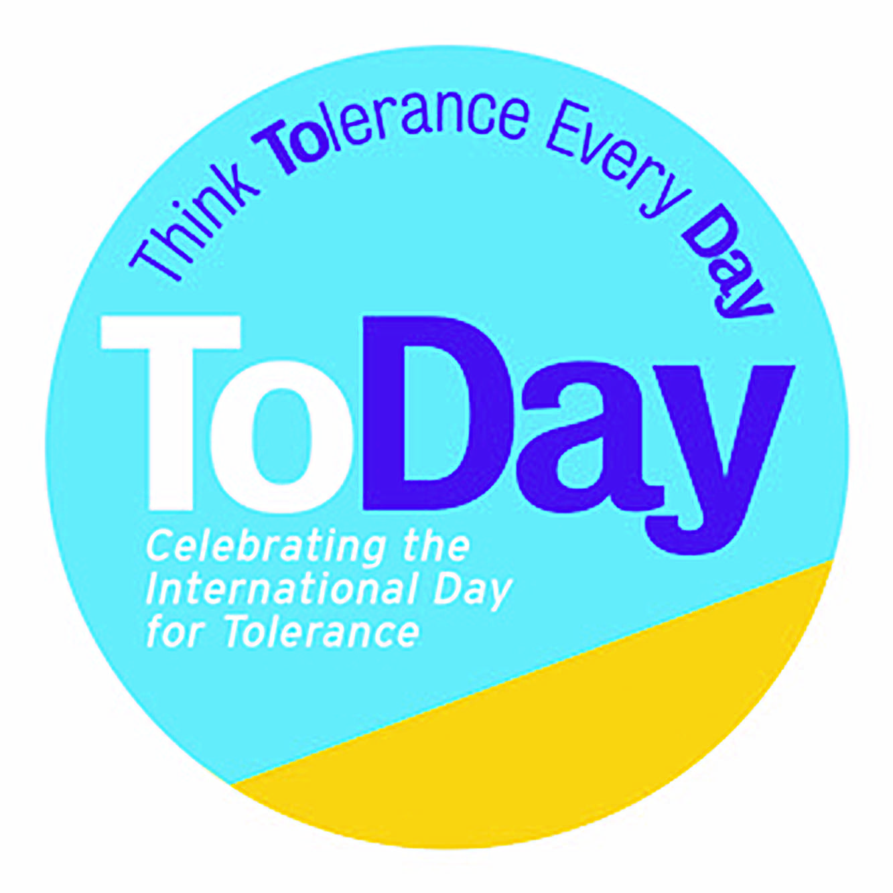

***‘The Butter Battle’ by Dr Seuss***

***KS2 Upper English***

|  |  |  |  |
| --- | --- | --- | --- |
| **Themes:** Conflict resolution, Tolerance of difference. | | | |
| **Year Group/**  **Subject** | Key-stage 2 Upper  English  30-minute lesson with optional follow-up work |  |
| **Skills being Developed** | Listening and communicating  Building empathy  Controlling emotions  Problem solving |  |
| **Learning**  **Objectives /Curriculum area** | Review literary elements of symbolism and satire.  Discuss contemporary and historical connections to situations in texts.  Identifying and discussing themes and conventions in and across a wide range of writing  Synthesize information to draw conclusions about a text's message.  Understand what they read by:   1. Predicting what might happen from details stated and implied 2. Summarising main ideas drawn from more than one paragraph, identify key details to support the main ideas 3. Identifying how language, structure and presentation contribute to meaning 4. Understanding the meaning of narrative in poetry 5. Improving speaking and listening skills by focusing on the National Curriculum Level requirements and Assessment Foci and aiming to address these during group practice 6. Listening and responding constructively to others and modifying their own views accordingly |  |
|  |  | **Timing** |
| **Stimulus** | Begin by explaining you are going to read/ listen to (link below) the Butter Battle by Dr. Seuss. Older children still love picture books! Allow time for students to comment on Dr Seuss books or similar they remember from their childhood. What can they possibly learn now from a rhyming children’s picture book Do they know any other narrative poems? <https://www.youtube.com/watch?v=ut1CSRmVp0I> | 2 mins |
| **Guided Discussion** | Read/Play the Butter Battle Book video to the class, asking students to listen for details that compare to historical or current events.  Once the reading is complete, ask students to share immediate thoughts and reactions to the book. It's likely that students will see parallels to current events, (Trump’s wall/Covid19) if not historical events. | 9 mins  3 mins |
| **Class Activity** | 1. Introduce the following definition of satire to the students: ‘A literary work that ridicules its subject through the use of techniques such as exaggeration, reversal, incongruity, and/or parody in order to make a comment or criticism about it.’ 2. Arrange students into four to five small groups and give each an identity (Yooks or Zooks). 3. Explain that the goal for each group is to think about how the Zooks/Yooks conflict began and how it could have been avoided altogether 4. Run Question Storm activity *(Appendix 1)* 5. Then ask them at which points in the story they thought the escalation could have been halted.    1. By whom?    2. How?   Record results on whiteboard/flipchart. | 3 mins  5 mins |
| **Independent work** | **Create your own satire:**  Ask them to come up with their own ending to the story- at least one paragraph in length.  **OR**  Draw a large picture of the new ending you imagine.  **OR**  Imagine a disagreement over something ‘funny’ between two invented sides. Write a newspaper article, reporting on your imagined conflict or on theZooks/Yooks conflict. Make sure you include your 6 Honest Friends: Who? What? When? Where? Why? and How?  **OR**  Letter Writing: Using the questions you’ve come up with write a letter from the Zooks to the Yooks explaining how and why you think you can live harmoniously instead of in conflict. |  |
| **Plenary** | **What did we learn?** |  |
| Class discussion/  homework | Ask Students to think about how the Zooks/Yooks conflict began and how it could have been avoided altogether.  Ask them to come up with creative solutions and compromises to the existing conflict.  What if one side had managed to overcome the other, what might have happened then and why? What elements of human nature are at play? Can we override them with strategies for conflict resolution?*(Appendix 2)*  Follow up work could include: writing a Zooks/Yooks Peace Treaty. Or to research another narrative poem that tells a story: (e.g.The Owl and The Pussycat).  Follow up lesson: see **Reds v Blues**  Young Journalist Competition | 8 mins |

**Appendix 1 - Question Storm**

This is a twist on a brain-storm and gets pupils comfortable and capable of generating volumes of their own simple questions. It takes between 5-15 mins to do – you can spend as long as you like discussing the results. It can be used to: *link to prior learning; identify students’ own areas of interest within a topic; identify areas for further independent research; provide a launch-pad for discussion; homework or project activities*

|  |  |
| --- | --- |
| Question- Storm Rules | * First chose the stimulus/topic you want to question-storm * The task is then to generate as many questions as possible, without judgement or editing * [We use Who? What? When? Where? Why? and How?](http://www.toleranceday.org/uploads/2/4/7/3/24739493/truth_detectives_tool_kit_with_characters.pdf) [(See printable ‘Question Friend Characters for KS1 and 2](http://www.toleranceday.org/uploads/2/4/7/3/24739493/truth_detectives_poster.pdf). Use a giant egg timer/buzzers for fun) * Pupils have 2 minutes to come up with questions and then switch to a new question stem. You might want to do all stems in 2 minutes for older pupils OR * If writing down is an issue, doing hands up is great; 1 minute for each question stem/friend * If it’s proving tricky, ask pupils to write their thought as a statement and then help them turn that into a question |
| Practice question-storm – instructions for pupils | * Let’s do a question-storm about X * Make sure you have paper and pen * The game is to write down as many questions as you can * You have 1 minute per question character * The egg timer will show you how long you have and a buzzer will sound when it’s time to move onto the next character * Remember, there are no good or bad/right or wrong questions   On your marks get set, go! |
| Results | How you collect the results is up to you:   * Oracy and recording to track learning are ideal * Pupils pick their top 1-3 and highlight in their book and/or share with the class OR * Create a set of ‘community questions’ - Paired share for 2 mins with neighbour to your left to talk about your favourite questions * As a table take 2 mins pick your top 3 as a group to share with the class * Write up on flipchart * *See if there are an obvious top 3-5 for the class* |

**Appendix 2 - Conflict Resolution Strategy**

**KS1-KS2**

**Calm***: Breathe. Aim for a 4-in, 2-hold, 6-out cycle – breathe in for 4 seconds, hold for 2 seconds, then breathe out for 6 seconds. Be calm, name the feeling: ‘anger’ ‘fear’ ‘sadness’ ‘humiliation’*

**Listen**: Use questions, focus your attention, begin to understand

**Identify:** Feel and understand what someone else feels

**Cooperate:**

* Describe the problem
* Think of LOTS of solutions
* Think of consequences (if…then…)

Choose best solution

**KS2 Upper-KS3**

***Control emotion****: Breathe. Aim for a 4-in, 2-hold, 6-out cycle – breathe in for 4 seconds, hold for 2 seconds, then breathe out for 6 seconds. Be calm, name the feeling: ‘anger’ ‘fear’ ‘sadness’ ‘humiliation’*

1. Recognise EVERYONE’s innate bias: we all think we are ‘right’. Take perspective, look at facts, ask for an un-biased view.
2. Resist the urge to threaten or use ultimatums - because of the common human tendency to treat others the way they’re treated, people tend to respond to threats in kind, leading to an escalatory spiral and worsening conflict.
3. Override our hardwired tendency to Us v Them thinking: look for what we have in common.
4. Look even deeper: is this really *just* about a sandwich/insult/football incident/cultural difference?
5. Carefully examine your own motivations: Think about what outcome is really best for you and find creative solutions to compromise.